Section I: Scenario Demographics

Scenario Title: | ASA Overdose
Date of Development: | 30/06/2015 (DD/MM/YYYY)
Target Learning Group: | Juniors (PGY 1 – 2) Seniors (PGY ≥ 3) All Groups

Section II: Scenario Developers

Scenario Developer(s): | Kyla Caners
Affiliations/Institution(s): | McMaster University
Contact E-mail (optional): | kcaners@gmail.com

Section III: Curriculum Integration

Learning Goals & Objectives
Educational Goal: | To allow learners to practice management of a rare presentation with critical steps in its management.
CRM Objectives: | Clearly communicate to team the importance of findings as well as management steps.
Medical Objectives: | - Recognize the importance and severity of a salicylate overdose.  - Demonstrate appropriate initial investigations and management of a salicylate overdose.  - Recognize the significance of a change in mental status in the context of a salicylate overdose.

Case Summary: Brief Summary of Case Progression and Major Events
22 year-old female presents saying she just ingested 60 tablets of ASA because she wants to die. Her mom found her while she was finishing the bottle of 325mg tabs approximately 60 minutes ago and called EMS. The patient is complaining of nausea and tinnitus and is tachypneic. The team should consider activated charcoal and alkalinize the urine. If they do not initiate treatments, they will receive a critical VBG showing a mixed respiratory alkalosis and metabolic acidosis. The patient will then become somnolent. The team will be expected to check her blood sugar and call for dialysis. They will also need to intubate and recognize the need to hyperventilate and dialyze.

References
Marx, J. A., Hockberger, R. S., Walls, R. M., & Adams, J. (2013). Rosen's emergency medicine: Concepts and clinical practice. St. Louis: Mosby.

Section IV: Scenario Script

A. Scenario Cast & Realism
Patient: | Computerized Mannequin |  |  |  |  | Realism:  Select most important dimension(s) |  |  | Conceptual
 | Mannequin |  |  |  |  |  |  |  | Physical
 | Standardized Patient |  |  |  |  |  |  |  | Emotional/Experiential
 | Hybrid |  |  |  |  |  |  |  | Other:
 | Task Trainer |  |  |  |  |  |  |  | N/A
Confederates | Brief Description of Role
None. | **Could add a difficult mother for seniors
B. Required Monitors
EKG Leads/Wires |  |  | Temperature Probe |  |  |  | Central Venous Line
NIBP Cuff |  |  | Defibrillator Pads |  |  |  | Capnography
Pulse Oximeter |  |  | Arterial Line |  |  |  | Other:
C. Required Equipment
Gloves |  |  | Nasal Prongs |  |  |  | Scalpel
Stethoscope |  |  | Venturi Mask |  |  |  | Tube Thoracostomy Kit
Defibrillator |  |  | Non-Rebreather Mask |  |  |  | Cricothyroidotomy Kit
IV Bags/Lines |  |  | Bag Valve Mask |  |  |  | Thoracotomy Kit
IV Push Medications |  |  | Laryngoscope |  |  |  | Central Line Kit
PO Tabs |  |  | Video Assisted Laryngoscope |  |  |  | Arterial Line Kit
Blood Products |  |  | ET Tubes |  |  |  | Other:
Intraosseous Set-up |  |  | LMA |  |  |  | Other:
D. Moulage
None required. Could have empty ASA bottle that family members brought in.

E. Approximate Timing
Set-Up: |  | 3 min |  | Scenario: | 12 min |  |  | Debriefing: |  | 20 min

Section V: Patient Data and Baseline State

A. Clinical Vignette: To Read Aloud at Beginning of Case
Cassandra Acton is a 22 year-old female presents saying she just ingested 60 tablets of ASA because she wants to die. Her mom found her while she was finishing the bottle of 325mg tabs approximately 60 minutes ago and called EMS. The patient is complaining of nausea and tinnitus.
B. Patient Profile and History
Patient Name: Cassandra Acton |  |  |  |  |  | Age: 22 |  |  |  |  |  |  |  | Weight: 70kg
Gender: M F |  |  |  |  |  | Code Status: Full
Chief Complaint: Overdose
History of Presenting Illness: Ingested 60 tablets of ASA approximately 90 minutes ago. Found by her mom while doing so. Intent was to die.
Past Medical History: |  | None |  |  |  |  | Medications: |  |  |  |  | None
Allergies: None
Social History: Lives with mom and stepdad as well as stepsister. (Recent marriage of mom & stepdad.)
Review of Systems: |  | CNS: |  |  | Ongoing suicidal ideation.
 |  | HEENT: |  |  | Tinnitus.
 |  | CVS: |  |  | No CP, no palps.
 |  | RESP: |  |  | Mildly SOB.
 |  | GI: |  |  | Nausea ongoing.
 |  | GU: |  |  | Nil.
 |  | MSK: |  |  | Nil. |  |  |  |  |  |  |  | INT: |  | Nil.
C. Baseline Simulator State and Physical Exam
No Monitor Display |  |  |  | Monitor On, no data displayed |  |  |  |  |  |  | Monitor on Standard Display
HR: 115/min |  |  | BP: 100/60 |  |  |  |  | RR: 30/min |  |  |  |  |  |  | O₂SAT: 97%
Rhythm: Sinus tach |  |  | T: 37.6ºC |  |  |  |  | Glucose: 5.3 mmol/L |  |  |  |  |  |  | GCS: 15 (E4 V5 M6)
General Status: Very tachypneic but otherwise well-seeming.
CNS: | PERLA. Normal EOM.
HEENT: | No signs HI.
CVS: | No murmur.
RESP: | Tachypneic, but no increased WOB. GAEB with no adventitious sounds.
ABDO: | Soft, NT.
GU: | Nil.
MSK: | No signs trauma. |  |  |  |  |  |  |  | SKIN: | No signs cutting.

Scenario States, Modifiers and Triggers
Patient State | Patient Status | Learner Actions, Modifiers & Triggers to Move to Next State
1. Baseline State  Rhythm: Sinus tach  HR: 115/min  BP: 100/60  RR: 30/min  O₂SAT: 97%  T: 37.6ºC | Patient awake, answering questions. Complaining of nausea and tinnitus. | Learner Actions  - IV, monitors  - Tox bloodwork including VBG, osmols, ASA, APAP, EtOH  - ECG  - Cap sugar: 5.3  - Call poison control  - Activated charcoal  - IV NS 1L bolus | Modifiers  Changes to patient condition based on learner action  Triggers  For progression to next state  - 4 min 2. VBG back
2. VBG Back  Vitals unchanged | **State starts with giving team critical VBG results** | Learner Actions  - Alkalinize urine  - Call poison control if haven’t  - Insert foley  - Bolus IV fluid  - Correct K depletion | Modifiers  Triggers  - 7 min 3. Somnolent  - Urine alkalinization started 3. Somnolent
3. Somnolent  RR 26  O₂SAT 93% | Patient now unresponsive. GCS 8 (E2 V2 M4) | Learner Actions  - Cap sugar: 3.8  - Give 1 amp D50 iv  - Prepare for intubation  - Elevate HOB  - Call for dialysis | Modifiers  - No cap sugar by 2 min into state patient seizes  - O₂ applied O₂SAT to 95%  Triggers  - Intubation 5. Post-Intubation  - 12 min 6. ASA Back
4. Seizure  HR 150  BP 160/90 | Patient actively seizing | Learner Actions  - Check cap sugar: 3.8  - Give 1 amp D50 iv  - Continue urine alkalinization | Modifiers  Triggers  - D50 given 6. ASA Back
5. Post-Intubation  HR 105  BP 95/55  O₂SAT 100%  RR vent settings indicated by team | **Give team ASA level at onset of this state** | Learner Actions  - Set ventilator with high RR  - Continue urine alkalinization  - Call ICU  - Call Nephrology for dialysis  - Post-intubation CXR  - Administer sedation  - Elevate HOB | END CASE PRN with ICU arriving.
6. ASA Back  Same as previous | **Give ASA level at onset of this state** | Learner Actions  - Call Nephrology for dialysis  - Continue urine alkalinization  - Call ICU  - Call poison control if haven’t yet | END CASE PRN with ICU arriving.
Section VI: Scenario Progression

Images (ECGs, CXRs, etc.)
ECG at presentation  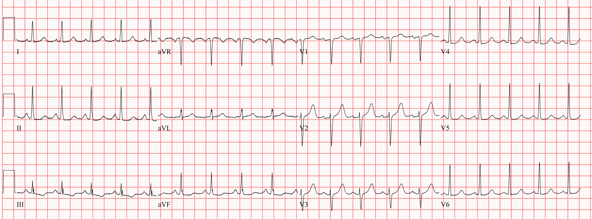  Source: http://en.ecgpedia.org/wiki/File:Sinustachycardia.jpg | CXR at presentation  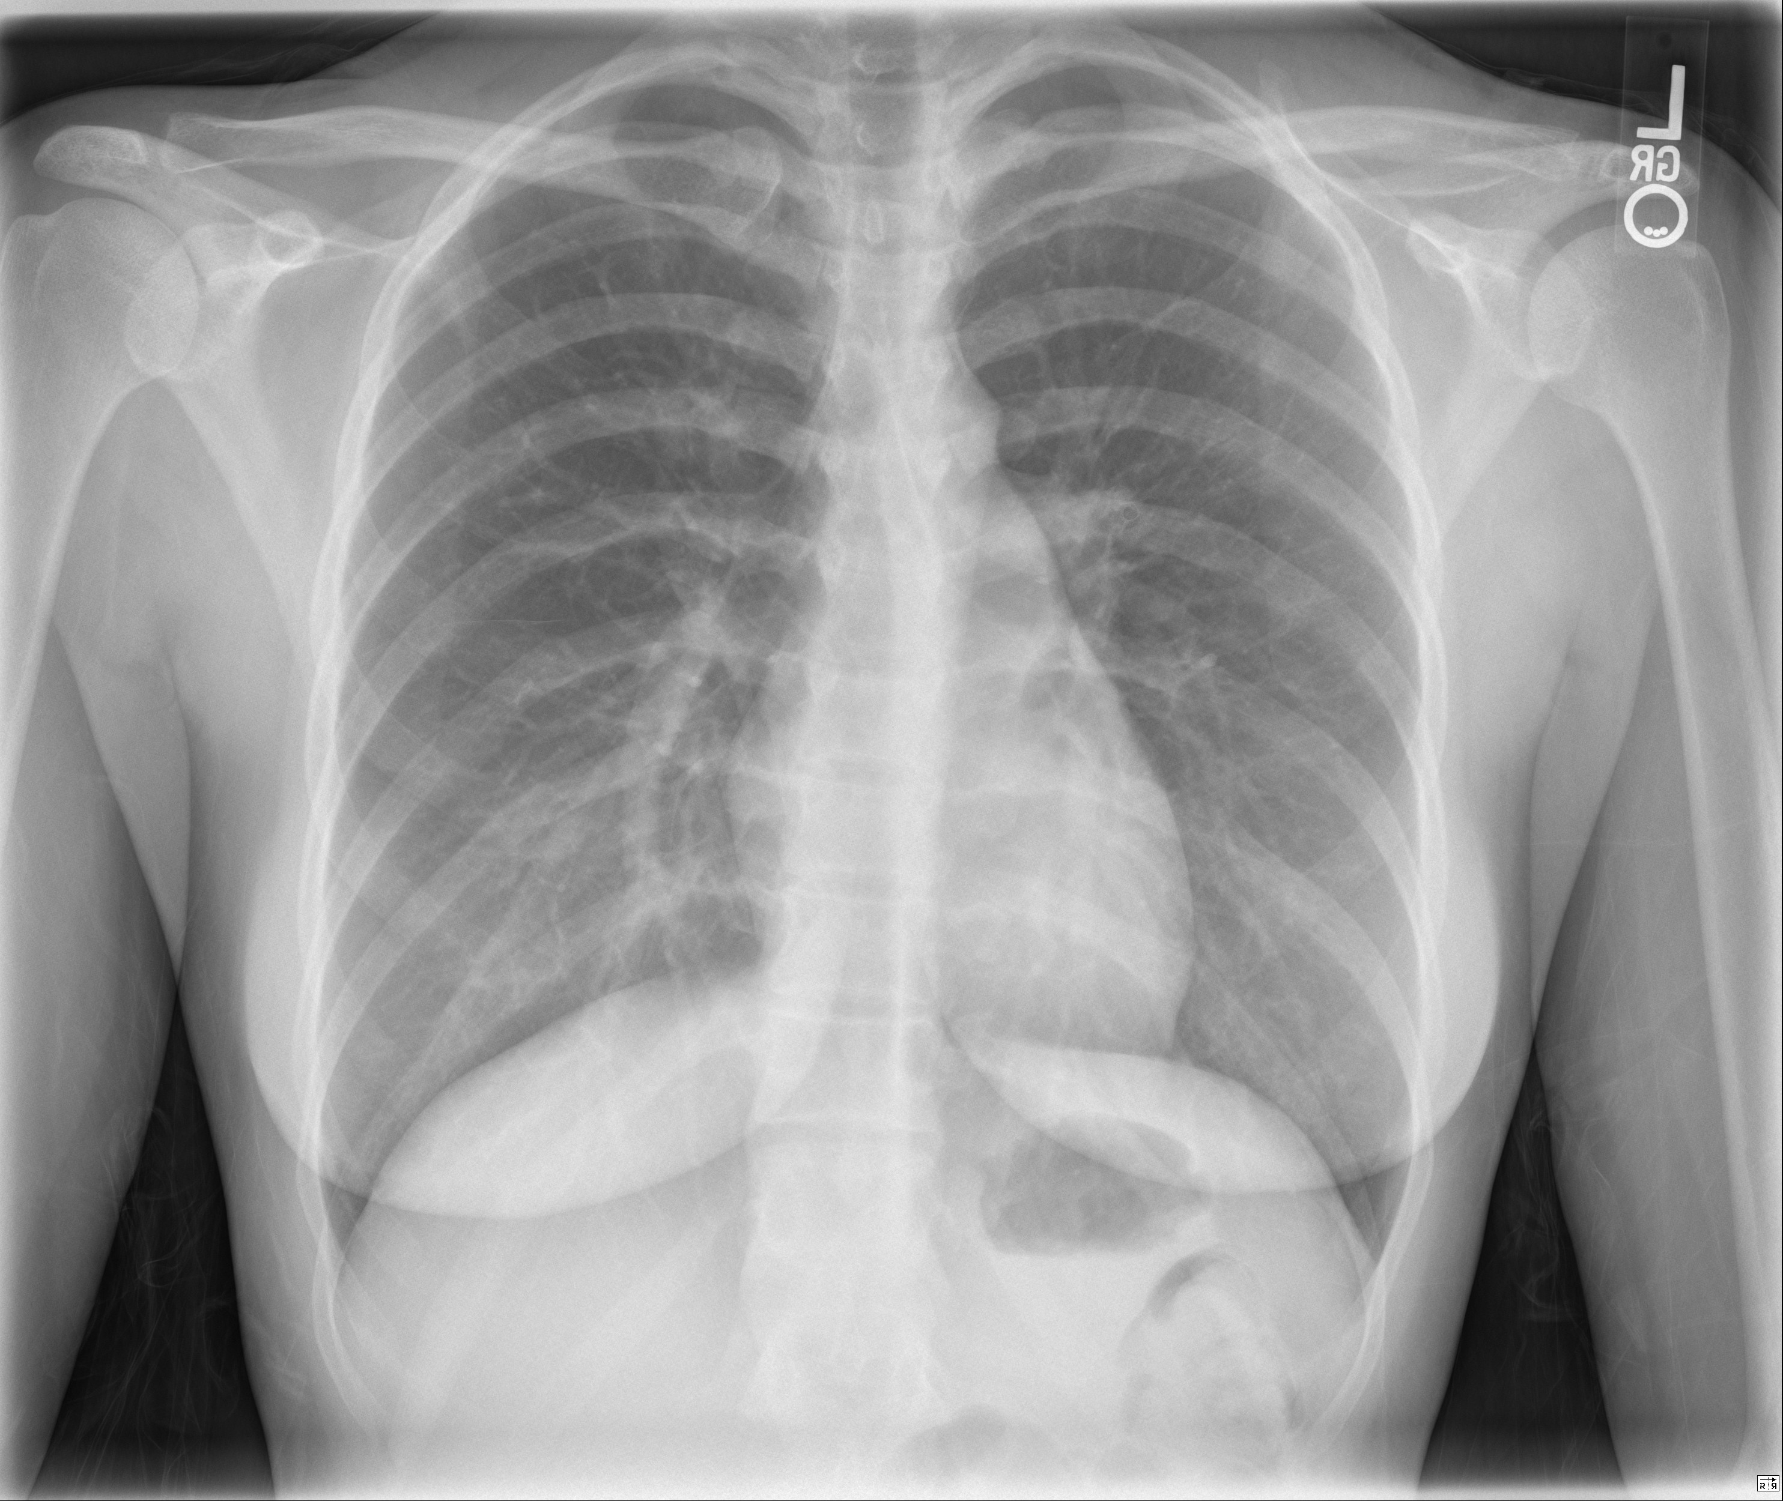  Source: http://radiologypics.com/2013/01/25/normal-female-chest-radiograph/
Post-intubation CXR
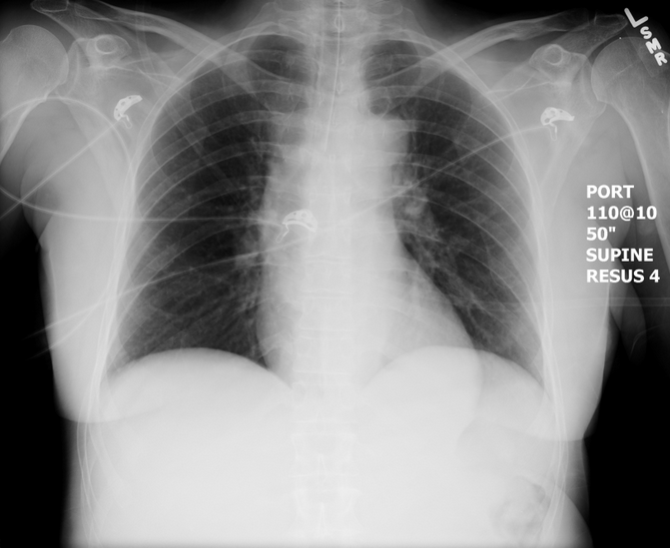
Source: https://emcow.files.wordpress.com/
2012/11/normal-intubation2.jpg
Section VII: Supporting Documents, Laboratory Results, & Multimedia

Laboratory Results
Na: 135 | K: 3.2 |  | Cl: 100 |  | HCO₃: 8 |  | BUN: 7 |  | Cr: 80 |  | Glu: 5.0
VBG |  | pH: 7.30 |  | PCO₂: 18 |  | PO₂: 40 |  | HCO₃: 12 |  | Lactate: 4
ASA: 7.5mmol/L

Section VIII: Debriefing Guide

General Debriefing Plan
Individual |  | Group | With Video | Without Video
Objectives
Educational Goal: | To allow learners to practice management of a rare presentation with critical steps in its management.
CRM Objectives: | Clearly communicate the importance of findings and management to the team.
Medical Objectives: | - Recognize the importance and severity of a salicylate overdose.  - Demonstrate appropriate initial investigations and management of a salicylate overdose.  - Recognize the significance of a change in mental status in the context of a salicylate overdose.
Sample Questions for Debriefing
- What are the clinical features of ASA overdose?
- What are the indications for urine alkalinization? How do you do it?
- Why do you think the patient became more comatose? What causes of this are important to consider in an ASA overdose?
- What are the indications for dialysis in an ASA overdose?
- What acid-base disturbances are seen in an ASA overdose? How does the anion gap change?
- Do you feel that your team was on the same page about the severity of this overdose? Do you feel you were all aware of what needed to be done? If not, do you think the leader managed to show why?
- Why is intubation in an ASA overdose worrisome? What can you do pre and post intubation to mitigate these risks?
Key Moments
Recognition of metabolic acidosis and initiation of urine alkalinization
Management of altered LOC
Post-intubation management (calling consultants urgently)

